Sprint 3 Plan

DnD Assistant App  
5/4/22–5/17/22

Goal: Create a website that allows users to create a character

User Story:

1. As a player, I want to create a character, so that I can play the game (8)
   1. Choosing (4)
      1. race, class, background, ability score, equipment
   2. pushing character information into database (2)
2. As a player, I want to save my character, so that I don’t have to create a new one every time (2)
   1. Taking previous information and pushing to firebase
3. As a player, I want a walkthrough of the process of creating a character, so that I don’t have to google it (3)
   1. character creation process tips along the way
4. As a player I want to be able to search through a list of spells by name, so that I don’t need to scroll through a long list (1)
5. As a player I want to be able to filter a list of spells by its attributes, so I can look for a particular spell (1)
6. As a player I want to be able to bookmark my spells, so that I can compare them and have quick access to my favorites (1)

Team Roles:

* Brian
  + Product Owner, Developer
* Brandon
  + Developer
* Mateo
  + Developer, Scrum master
* David
  + Developer
* Cynthia
  + Developer

Initial task assignment:

* Brian
  + Tips
  + Scrapping
  + Front-end
* Brandon
  + Push final character into Firebase
  + Back-end
* Mateo
  + Front-end
  + Character creation buttons
* David
  + Fetch information from DnD api
  + Back-end
* Cynthia
  + Front-end
  + Character creation cards

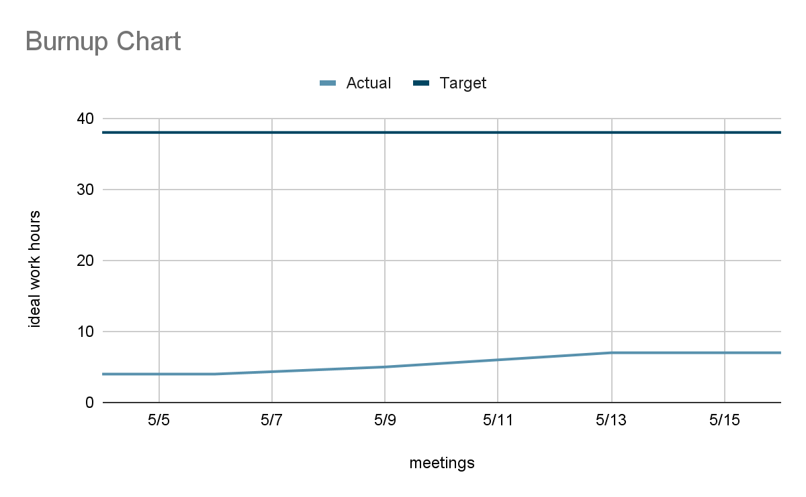

SCRUM board: https://trello.com/invite/dndassistantapp/2ea0443f7a8af527f19901d5f9fc6dc9

SCRUM times:

* Monday 7:00 pm
* Wednesday 4:00pm
* Friday 4:30 pm (TA)
* Friday 5:15 pm